NOTICE OF PUBLIC HEARING ON TAX INCREASE
A tax rate of $0.0300 per $100 valuation has been proposed by the governing body of Hidalgo County Emergency Service District No. 2.
PROPOSED TAX RATE | $0.0300 per $100
NO-NEW-REVENUE TAX RATE | $0.0289 per $100
VOTER-APPROVAL TAX RATE | $0.0316 per $100
The no-new-revenue tax rate is the tax rate for the 2026 tax year that will raise the same amount of property tax revenue for Hidalgo County Emergency Service District No. 2 from the same properties in both the '2025 tax year and the 2026 tax year.
The voter-approval rate is the highest tax rate that Hidalgo County Emergency Service District No. 2 may adopt without holding an election to seek voter approval of the rate.
The proposed tax rate is greater than the no-new-revenue tax rate. This means that Hidalgo County Emergency Service District No. 2 is proposing to increase property taxes for the 2026 tax year.
A PUBLIC HEARING ON THE PROPOSED TAX RATE WILL BE HELD ON September 8, 2026 AT 12:OOpm AT Monte Alto Recreation Center, 25164 FM 88, Monte Alto, Texas 78538..
The proposed tax rate is not greater than the voter-approval tax rate. As a result, Hidalgo County Emergency Service District No. 2 is not required to hold an election at which voters may accept or reject the proposed tax rate. However, you may express your support for or opposition to the proposed tax rate by contacting the members of the Board of Directors of Hidalgo County Emergency Service District No. 2 at their offices or by attending the public hearing mentioned above.
YOUR TAXES OWED UNDER ANY OF THE RATES MENTIONED ABOVE CAN BE CALCULATED AS FOLLOWS:
Property tax amount= (tax rate) x (taxable value of your property)/100
FOR the proposal: Jason Pena Robert Escobar
Anna Flores
AGAINST the proposal: N/A
PRESENT and not votng:N/A
ADöENT; Commissioner Marlene Hinojosa
Visit Texas.gov/PropertyTaxes to find a link to your local property tax database on which you can easily access information regarding your property taxes, including information about proposed tax rates and scheduled public hearings of each entity that taxes your property.
The 86th Texas Legislature modified the manner in which the voter-approval tax rate is calculated to limit the rate of growth of property taxes in the state.
The following table compares the taxes imposed on the average residence homestead by Hidalgo County
Emergency Service District NOD 2 last year to the taxes proposed to be imposed on the average residence homestead by Hidalgo County Emergency Service District No. 2 this year.
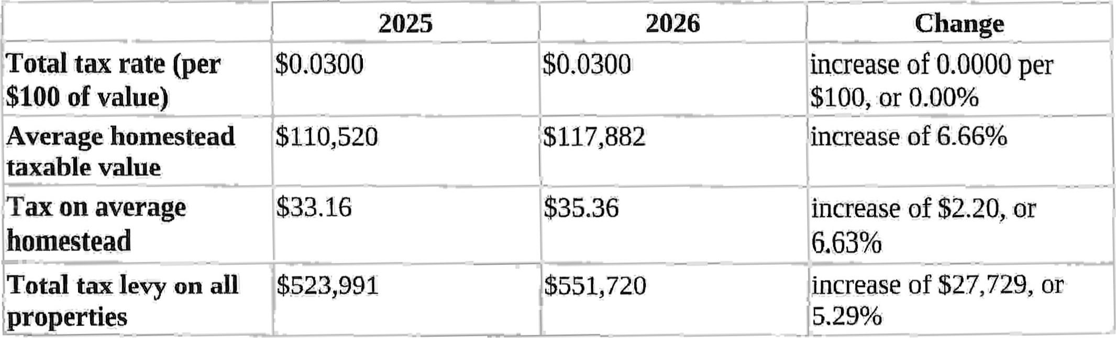
For assistance with tax calculations, please contact the tax assessor for Hidalgo County Emergency Service District No. 2 at 956-318-2157 or propertytax@hidalgocountytax.org, or visit www.hidalgocountytax.org for more information.

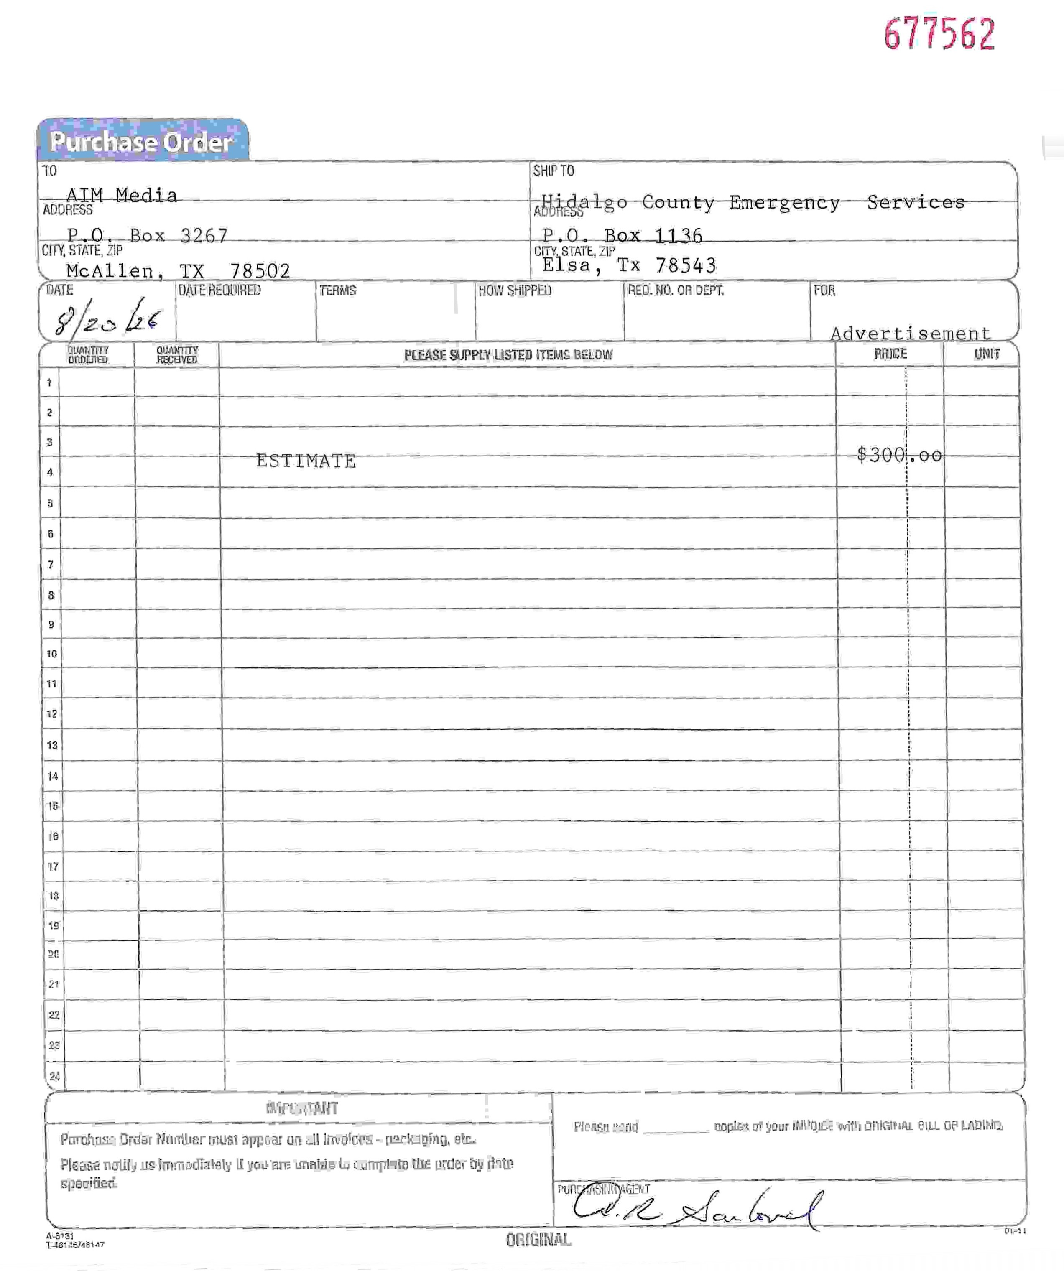
677562

